Project report

* 1.INTRODUCTION

**OVERVEIW:-**

To summarize and brief in short, Weather App is the application of science and technology to predict the conditions of the atmosphere for a given location and time. People have attempted to predict the weather informally for millennia and formally since the 19th century.

The system constantly monitors temperature using temperature sensor, humidity using humidity sensor and also for rain. Weather monitoring system deals with detecting and gathering various weather parameters at different locations which can be analysed or used for weather forecasting.

**PURPOSE:-**

The system constantly monitors temperature using temperature sensor, humidity using humidity sensor and also for rain. Weather monitoring system deals with detecting and gathering various weather parameters at different locations which can be analysed or used for weather forecasting.

The Weather App is a simple project developed using JavaScript, CSS, and HTML. This project is an interesting project for simply weather forecasting. The user can check the condition of the present-day climate probability and predict whether the day is a cloudy or sunny day.

* **2.LITERATURE SURVEY**

**2.1EXISTING PROBLEM FOR WEATHER APP:-**

Weather App Not Opening – In today’s post, we will see about Weather App and try to find out why it is not working. We are sure that you’d like to ask some questions about Weather App, such as

* What is weather app ?

Weather is a weather forecasting mobile application available for free to download for Google Play Store and Apple App Store. It allows users to see the weather conditions, forecast, temperature, and other related metrics of the device current location, as well as a number of other cities.

* Why Weather App is not starting?

There may be several reasons behind not working of Weather App.

Maybe the Weather App server is down or the app is under maintenance. Other than this, other common issues can interrupt your service.

But the most common problem is Weather App is not opening. This can be a real problem, for obvious reasons, especially for those who use it on daily basis.

If you are facing trouble while accessing Weather App, read on. You will find several fixes for Android and other devices.

Below is the most common solution which may help to access Weather App.

Wait for some time because the app may be in maintenance mode.

Maybe the server is down, so wait for some time.

Check Your Internet Connection.

If the above solutions did not work then you can try more tricks to open the App.

* Update Weather App
* Restart Your Phone.
* Check Device Compatibility.
* Check Device date and time setting.
* Update Your Device.
* Clear App cache file from app Settings.
* Why is the Weather App is not working properly?
* Is Weather App is banned?

No, currently Weather App is not banned.

* Why is Weather App showing Unable to Connect to Server?

This is because the Weather App server is busy or down.

* Why Weather App is not Working Today?

1.Maybe the server is down, or it is under maintenance.

2.Check Your Internet Connection.

* Facing login issues in Weather App?

If you face login issues, then check the data connection and the login credentials.

* Is Weather App is Closed?

No, currently Weather App is not closed.

**2.2PROPOSED SOLUTION FOR WEATHER APP:**

**1. Research about Your Competitors:**

Weather apps give the users’ weather forecasts based on hours and even days.

A weather app that offers an attractive user interface and provides highly accurate forecasting will take the lead over its rivals.

Therefore, you must first research the apps of your main competitors to study their strengths and weaknesses before you create your app.

Researching the apps of your successful competitors will give you a clue regarding what features you must add and what to avoid in the interface of the app.

You can also go through the reviews of these apps on the various platforms to know what extra features their users want and try to include them in your app to get an edge over them.

**2. Get the Tools Needed for Accurate Weather Forecasting:**

After studying your competitors, you should look for a source of highly reliable and accurate data for weather forecasting that can be integrated with your app.

While there are many weather forecast API providers available in the market, here we will walk you through the best of the bunch.

Weather Underground API

It is a well-known weather forecasting company that comprises mobile services to provide meteorological data sourced from multiple weather stations.

The company has created a WeatherUndergound API which developers can use to develop a weather app.

Besides this, the company allows third-party developers to create APIs and share it with them.

Some of the API data packages that it offers include the following:

**DATA CORE**: It offers the most basic weather APIs, radar, and satellite data.

**ENHANCED CURRENT CONDITION:** It includes their highest resolution weather data.

**SEVERE WEATHER:** It offers real-time weather forecasting as well as trailing estimates of any severe weather pattern.

**ENHANCED FORECAST**: It provides highly sophisticated weather forecast models created by sophisticated algorithms.

**HISTORICAL DATA FORECAST**: It provides you with historical weather data observations.

**TRAFFIC DATA**: In this package, you get data from a massive network of 300 million sources in 50 countries regarding traffic and incident data.

OpenWeatherMap API is an open-source module that gives you highly accurate meteorological information from more than 40,000 weather stations spread worldwide.

Some of the highly refined data that it provides include the following:

Historical data of more than 1,20,000 cities around the world.

An interactive map including current weather patterns.

Highly accurate daily and weekly weather forecast of a city.

Multiple web maps show the cloud pattern, wind, precipitation, and temperature.

AccuWeather

It is another globally recognized company that provides comprehensive and highly accurate meteorological data to its registered users.

The reputed company has created AccuWeatherAPI through which it offers the following details to the third-party app developers:

Local meteorological data and current weather conditions.

Hourly and daily forecast.

Weather notifications.

Satellite and radar pictures.

Astronomical data and much more.

**3. Create an App that Stands Out:**

After you have collected all the research data and tools, the next logical step is to create the weather app for both Android and iOS platforms.

You have two options: Make a separate app for both platforms or create a hybrid app that works on both platforms simultaneously. If you don’t know the difference between native and hybrid, you can check this guide on native vs hybrid app development.

While building the app, the next thing you must keep in mind is its utility and easy accessibility to the user.

To make the app attractive, you should work hard on the user interface and try to make it interesting by including animations.

Some of the essential features that you must include in your weather app include the following.

* Real-time weather info and forecasting.
* Hourly and weekly forecasting with interactive maps.
* Push notifications for any weather alert.
* Sunset and sunrise time.
* Traffic condition and visibility.
* Support for the maximum number of devices.
* Attractive graphics and animated icons, and more.

**4. Decide USP of Your App:**

As your app will compete with thousands of similar apps in the market, you must provide a Unique Selling Proposition (USP) in your app that would help it to stand out in the crowd.

For example, you can include a USP that offers emergency details in case of natural disasters. For the same, you will require information regarding nearby shelters, emergency services, and other things.

**5. Choose App Monetization Methods:**

Once you have created the app, the next question that will appear in your mind is how to monetize a weather app?

You can earn money by providing advertising services integrated with this app. You can also offer a plan in which users can disable the ads and get some premium features.

Besides this, you can integrate various other monetization methods into your app.

**6. Launch Your App:**

After you have made the app and chosen the monetization method, the next step is to introduce it into the app market.

The Android PlayStore and the Apple App Store have distinct requirements for listing any app. After you have completed all the official documentation, your app will be listed.Now start your digital marketing campaign through multiple channels to create a buzz around the app launch which will interest people to download and try out its features.

* **3.THEORITICAL ANALYSIS**

**3.1 BLOCK DIAGRAM:-**

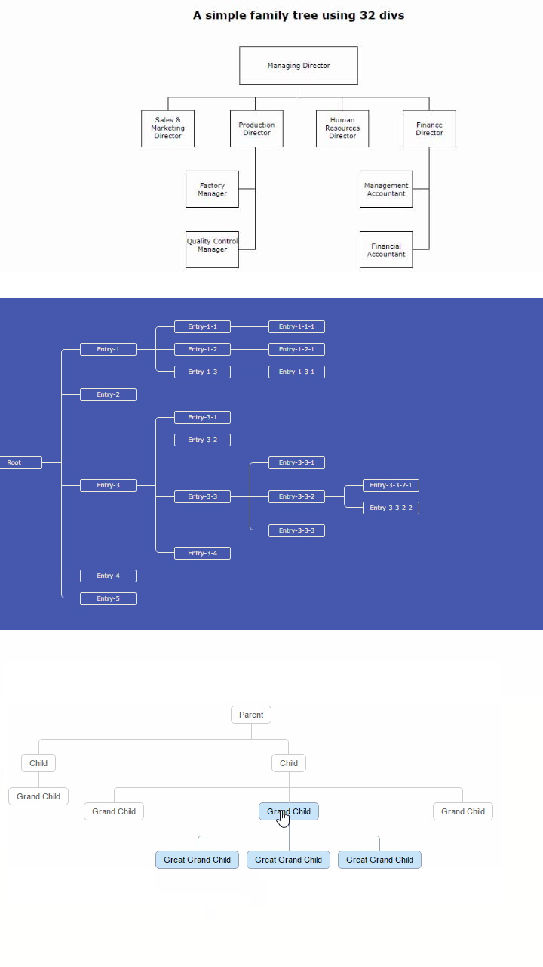

3.2 .HARDWARE/SOFTWARE DESIGNING :

**HARDWARE REQUIREMENTS:**

* Android mobile with a minimum version 2.2.
* 2) The processor is not less than 500MHZ.
* 3) RAM > 170mb.
* 4) SD card with a minimum of 512 MB.
* 5) Resolution is not less than 480*800pixs.

**SOFTWARE REQUIREMENTS:**

* visual studio code
* JavaScript.
* html
* 4)css
* 5)images
* **5.ADVANTAGES &DISADVANTAGES**

Advantages :-

Farmers can know when to plant or harvest their crops.

People can choose where and when to take their holidays to take advantages of good weather.

Surfers known when large waves are expected.

Regions can be evacuated if hurricanes or floods are expected.

Aircraft and shipping rely heavily on accurate weather forecasting.

Disadvantages :-

Weather is extremely difficult to forecast correctly

It is expensive to monitor-so many variables from so many sources

The computers needed to perform the millions of calculations necessary are expensive

The weather forecasters get blamed if the weather is different from the forecast

* **6.Applications:-**
* weather apps provide easy access to forecasts whenever you need them.
* Many apps tell you the high temperature for the day.
* They give you an hour-by-hour breakdown of temperatures, precipitation levels, air quality.
* Weather app is more to keep you informed and safe
* **7.future scope:-**

The demand for weather and climate forecast information in support of critical decision-making has grown rapidly during the last decade, and will grow even faster in the coming years. Great advances have been made in the utilization of predictions in many areas of human activities.